**VLOOKUP FORMULA**

**APPLYING VLOOKUP FORMULA**

**WHAT IS VLOOKUP**

**VLOOKUP** stands for 'Vertical Lookup'. It is a function that makes **Excel** search for a certain value in a column (the so called 'table array'), in order to return a value from a different column in the same row.

**USAGE**

Use VLOOKUP when you need to find things in a table or a range by row. For example, look up a price of an automotive part by the part number, or find an employee name based on their employee ID. The secret to VLOOKUP is to organize your data so that the value you look up (Fruit) is to the left of the return value (Amount) you want to find.

**HOW TO APPLY**

There are four pieces of information that you will need in order to build the VLOOKUP syntax:

1. The value you want to look up, also called the lookup value.
2. The range where the lookup value is located. Remember that the lookup value should always be in the first column in the range for VLOOKUP to work correctly. For example, if your lookup value is in cell C2 then your range should start with C.
3. The column number in the range that contains the return value. For example, if you specify B2:D11 as the range, you should count B as the first column, C as the second, and so on.
4. Optionally, you can specify TRUE if you want an approximate match or FALSE if you want an exact match of the return value. If you don't specify anything, the default value will always be TRUE or approximate match.

Now put all of the above together as follows:

=VLOOKUP(lookup value, range containing the lookup value, the column number in the range containing the return value, Approximate match (TRUE) or Exact match (FALSE)).

EXAMPLE:

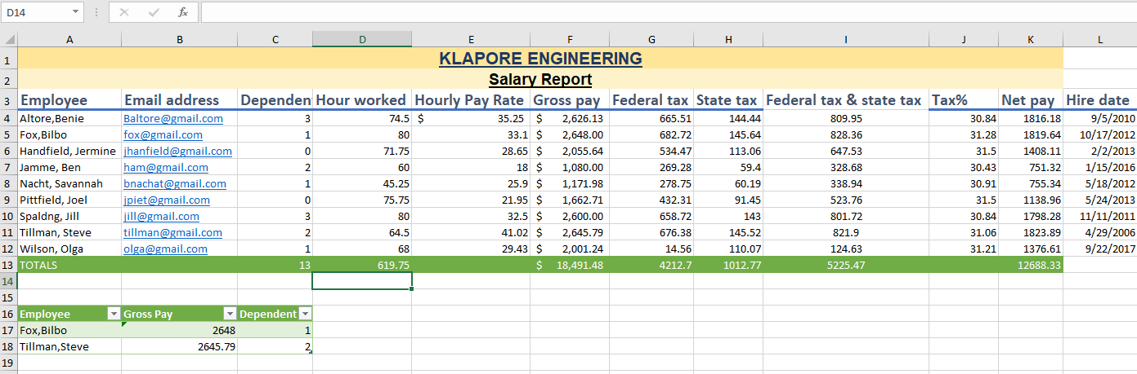

As shown above we have calculated VLOOKUP function to both Fox, Bilbo and Tillian, Steve.